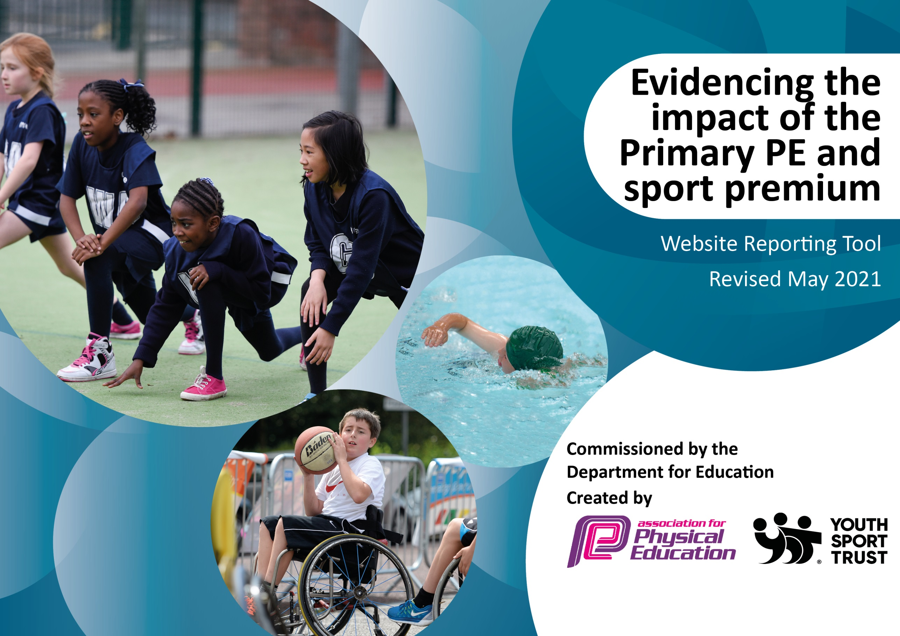
THINGWALL PRIMARY SCHOOL – PE ACTION PLAN 2021_22

It is important that your grant is used effectively and based on school need. The Education Inspection Framework (Ofsted 2019 p64) makes clear there will be a focus on ‘whether leaders and those responsible for governors all understand their respective roles and perform these in a way that enhances the effectiveness of the school’.

Under the Quality of Education criteria (p41) inspectors consider the extent to which schools can articulate their curriculum (INTENT), construct their curriculum (IMPLEMENTATION) and demonstrate the outcomes which result (IMPACT).

To assist schools with common transferable language this template has been developed to utilise the same three headings which should make your plans easily transferable between working documents.

Schools must use the funding to make additional and sustainable improvements to the quality of Physical Education, School Sport and Physical Activity (PESSPA) they offer. This means that you should use the Primary PE and sport premium to:

- Develop or add to the PESSPA activities that your school already offer
- Build capacity and capability within the school to ensure that improvements made now will benefit pupils joining the school in future years
- The Primary PE and sport premium should not be used to fund capital spend projects; the school’s budget should fund these.
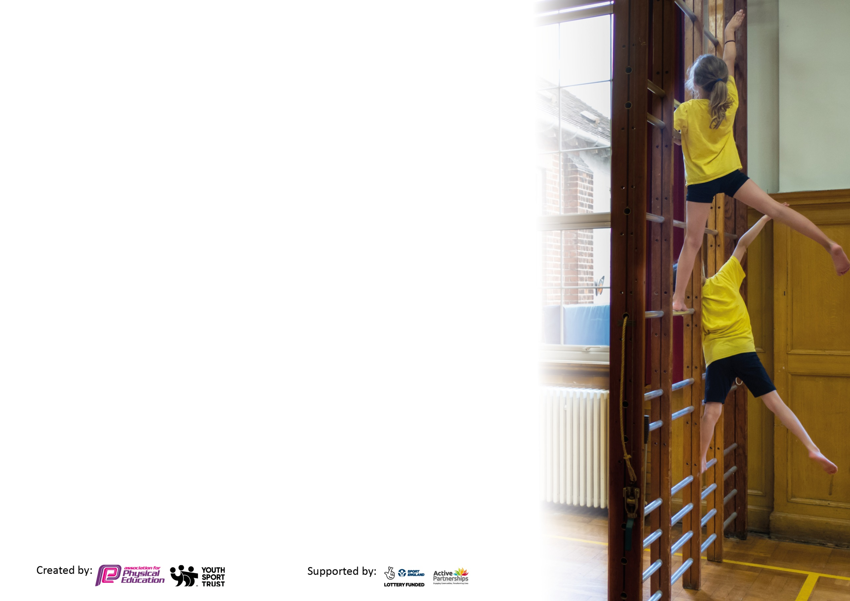
Please visit gov.uk for the revised DfE guidance including the 5 key indicators across which schools should demonstrate an improvement. This document will help you to review your provision and to report your spend. DfE encourages schools to use this template as an effective way of meeting the reporting requirements of the Primary PE and sport premium.

We recommend you start by reflecting on the impact of current provision and reviewing the previous spend.

Schools are required to publish details of how they spend this funding, including any under-spend from 2019/2020, as well as on the impact it has on pupils’ PE and sport participation and attainment by the end of the summer term or by 31st July 2021 at the latest.

We recommend regularly updating the table and publishing it on your website throughout the year. This evidences your ongoing self-evaluation of how you are using the funding to secure maximum, sustainable impact. Final copy must be posted on your website by the end of the academic year and no later than the 31st July 2021. To see an example of how to complete the table please click HERE.

Please note: Although there has been considerable disruption in 2020 it is important that you publish details on your website of how you spend the funding - this is a legal requirement.
Support for review and reflection - considering the 5 key indicators from DfE, what development needs are a priority for your setting and your pupils now and why? Use the space below to reflect on previous spend and key achievements and areas for development.
N.B. In this section you should refer to any adjustments you might have made due to Covid-19 and how these will influence further improvement.
Key achievements to date until July 2021: | Areas for further improvement and baseline evidence of need: 2021_22
-Premier Sports coaching staff continue to deliver a high standard of physical education to children and teaching staff’s proficiency has continued to improve.  - Our development plan to increase the range of after school and before school sports clubs, open to all children was delayed from March 2020 due to COVID restrictions. However, during the Summer Term, following an easing of COVID restrictions, a range of clubs were offered to pupils including; Dodgeball, Athletics, Judo, Basketball, Netball, and Multi-Sports.  - During lockdown, pupils present in school received daily activities led by teachers and Premier Sports staff. Pupils working from home were directed to a comprehensive list of online health and physical activities – Yoga & Pilates, Keeping your Mind Healthy, Orienteering routes for the Family, Clubs, Fitness Workouts and Dance, BBC ‘Supermovers’, Basic Skills to Practise with Your Child, and Parent and Child Activities.  - We used resources from the Youth Sports Trust for active learning in the classroom.  - Throughout the year, pupils competed in their ‘bubbles’, taking part in football, netball and other intra school competitions (with pupils setting scores for other classes to compete against) and enjoyed various house competitions including class sports days.  - Year 6 pupils (boys and girls) competed in a local football tournament.  - MSE led a ‘bootcamp’ for all pupils, with children completing a challenging obstacle course and receiving lessons in archery.  - Year 5 pupils experienced a range of outdoor activities including basic forest skills at an outward bound centre and Year 6 attended an activity day, enjoying climbing, abseiling, archery, orienteering and team building activities.  - We have introduced use of the Daily Mile to increase pupils’ fitness levels.  - The schools PE equipment has been improved and extended to cater for a wider range of sporting opportunities.  - Lunchtime sports leads have encouraged children to develop their skills and enjoy increased physical activity. | -To ensure that at least 35% of pupils attend extra-curricular sporting activities-the percentage of pupils taking part will be monitored from September 2021.  - Promote SEN and Pupil Premium pupils’ attendance at clubs and (aim for above 50% attendance)  (Data will be revised in light of COVID restrictions)  -To include at least two opportunities for pupils to take part in a personal challenge activity; these may be made available as part of our outdoor adventure programmes.  -To continue and extend the opportunities for pupils to take part in extra-curricular competition (both competitive and non-competitive) - at least 4 opportunities during the year.  -To resume PE lesson observations/support to ensure progression and quality physical education.  -To provide additional break time and lunchtime mini activities run by Play Leaders. Monitor to promote increased pupil participation during lunchtime, and ensure that children are physically active during the school day.  - Re-establish intra and inter school competitions to ensure pupils have competitive opportunities (set up timetable for Intra school and consult School Games Organiser for Inter School competitions).  -To improve upon the visibility of PE achievement in the school through VLE, noticeboards, display areas.  -To identify opportunities for engaging children who are less active across school (additional sporting exercise without competition)

Did you carry forward an underspend from 2019-20 academic year into the current academic year? NO
Total amount carried forward from 2020/2021 £ none
+ Total amount for this academic year 2021/2022 £ 17704
= Total to be spent and reported on or by 31st July 22 £ 17704

Meeting national curriculum requirements for swimming and water safety.  N.B Complete this section to your best ability. For example you might have practised safe self-rescue techniques on dry land which you can transfer to the pool when school swimming restarts.  Due to exceptional circumstances priority should be given to ensuring that pupils can perform safe self rescue even  if they do not fully meet the first two requirements of the NC programme of study. | To be completed April 2022
What percentage of your current Year 6 cohort swim competently, confidently and proficiently over a distance of at least 25 metres?  N.B. Even though your pupils may swim in another year please report on their attainment on leaving primary school at the end of the summer term 2021.  Please see note above. | %
What percentage of your current Year 6 cohort use a range of strokes effectively [for example, front crawl, backstroke and breaststroke]?  Please see note above. | %
What percentage of your current Year 6 cohort perform safe self-rescue in different water-based situations? | %
Schools can choose to use the Primary PE and sport premium to provide additional provision for swimming but this must be for activity over and above the national curriculum requirements. Have you used it in this way?

Action Plan and Budget Tracking
Capture your intended annual spend against the 5 key indicators. Clarify the success criteria and evidence of impact that you intend to measure to evaluate for pupils today and for the future.

Academic Year: 2021/22 | Total fund allocated: £ | Date Updated: from Sept 2021
Key indicator 1: The engagement of all pupils in regular physical activity – Chief Medical Officers guidelines recommend that primary school pupils undertake at least 30 minutes of physical activity a day in school |  |  |  | Percentage of total allocation:
Intent | Implementation |  | Impact | 90% (%)
Your school focus should be clear what you want the pupils to know and be able to do and about  what they need to learn and to  consolidate through practice: | Make sure your actions to achieve are linked to your intentions: | Funding allocated: | Evidence of impact: what do pupils now know and what can they now do? What has changed? | Sustainability and suggested next steps:
Introduce further sporting/physical activity opportunities. Deliver through coaching staff, play leaders, midday supervisors and Year 6 pupils  . | Weekly liaison with Premier Sports. Also seek out other providers such as Judo Education.  Reintroduce before and after-school clubs through Premier Sports and a range of other providers – see COVID risk assessment (activities subject to COVID restrictions)  Work with Premier Sport to embed Daily Mile for all classes  Continue to use ‘Wake up, Shake up’ and ‘Five-a-day Fitness’. Extend mindfulness during the day – (Jigsaw PSHE).  Develop role of Y6 Play Leaders to work alongside Midday Supervisors, developing active play.  (Use School Games Active Recovery Hub for ideas). Explore Jenny Mosely.  Provide storage and purchase new lunchtime equipment.  Develop outdoor environment and increase range of activities available for pupils via wall and floor games and various court markings for PE.  Purchase of football posts | £15,960  £2500 +  (Fundraising through PTA, POTS)  Funding via PTA initiative | Evidence – observations and discussions with pupils and staff; timetables.  Increased opportunities for all pupils to enjoy regular physical activity  Increased pupil motivation to improve personal goals (number of laps) increasing pupil physical and mental wellbeing and focus in lessons.  Increased leadership opportunities for Y6 pupils; Increased opportunities for pupils’ creative play.  Provision of improved play areas and opportunities for increased pupil enjoyment of playtime activities.  Increase the life of the equipment and enable safe storage. Also, easier to monitor quality and quantity of equipment levels.  Ability to host sports’ fixtures at ‘home’. | Continue to offer a wide range of activities encouraging all pupils to increase physical and mental fitness.  Continue to offer training and refresh, embed and develop staff skills.  Train pupils to look store equipment properly and to take care of it. Replace equipment annually, as required.
Key indicator 2: The profile of PESSPA being raised across the school as a tool for whole school improvement |  |  |  | Percentage of total allocation:
 |  |  |  | %
Intent | Implementation |  | Impact | **Part of Premier Sports Cost
Your school focus should be clear what you want the pupils to know and be able to do and about  what they need to learn and to  consolidate through practice: | Make sure your actions to achieve are linked to your intentions: | Funding allocated: | Evidence of impact: what do pupils now know and what can they now do? What has changed? | Sustainability and suggested next steps:
Promote the schools’ sporting success, inspiring others to join in, developing a positive ‘Can do’ attitude.  Continue to increase opportunities for competitive and non-competitive sport and activities including working with specialist coaches (subject to COVID restrictions)  Monitor and measure the impact of physical activity on fitness levels  Develop a love of the outdoors and explore opportunities for outward bound activities developing links to the whole school curriculum. | Celebrate pupil sporting achievements in assemblies, on the sport notice board, VLE and on Twitter.  See website ‘Association for Physical Education’  Assemblies for Judo. Look to introduce other activities (e.g. fencing and archery. Also Cheshire Cricket Club)  Reintroduce (beep test) and use certificates to reward progress.  School visits including residential trips to Burwardsley, Min Y Don and MSE.  MSE (Military Style Education) to lead sessions to develop bush skill and similar outdoor activities.  Explore possible Forest School visits for FS2 and KS1? |  | Evidence: newsletters, social media posts including Twitter  Wider range of activities made available to pupils to develop skills and knowledge and to inspire enthusiasm and love for sport and physical activity.  Improved level of fitness and participation in active sessions, increasing focus and concentration in all lessons  Pupils experience a range of new outward bound activities developing increased self-confidence, greater physical and mental fitness.  Pupils develop and practise survival skills. | Continue to promote and celebrate sport, raising its profile within the school.  Maintain links with specialist coaches to enhance the quality of provision in the future.  Pupils learn to appreciate the benefits of improved fitness and are inspired to improve levels of fitness further.  Pupils take these new experiences and develop skills to enjoy a range of outdoor activities in the future  Pupils learn about nature and develop a greater awareness for the environment.

Key indicator 3: Increased confidence, knowledge and skills of all staff in teaching PE and sport |  |  |  | Percentage of total allocation:
 |  |  |  | %
Intent | Implementation |  | Impact
Your school focus should be clear | Make sure your actions to | Funding | Evidence of impact: what do | Sustainability and suggested
what you want the pupils to know | achieve are linked to your | allocated: | pupils now know and what | next steps:
and be able to do and about | intentions: |  | can they now do? What has
what they need to learn and to |  |  | changed?
consolidate through practice:
Staff are confident and have necessary knowledge and skills to deliver quality lessons | To provide opportunities for Premier Sports to support the effectiveness of teacher/teaching assistant sessions to ensure succession of excellent standards.  Premier Sports to support staff with the organisation and delivery of intra-school competitions during PE sessions, and help to set up activities to measure improvements against a range of ‘personal bests’. These to be timetabled throughout the year. | Part of £15,960  cost for employing Premier Sport | Evidence: pupil and staff questionnaires.  Use of video  Staff and pupils engage enthusiastically in PE lessons  Majority of pupils make expected progress (or better) against identified objectives. | Staff knowledge and confidence developed to enhance quality and quantity of provision.
Key indicator 4: Broader experience of a range of sports and activities offered to all pupils |  |  |  | Percentage of total allocation:
 |  |  |  | %
Intent | Implementation |  | Impact | No additional cost
Your school focus should be clear | Make sure your actions to | Funding | Evidence of impact: what do | Sustainability and suggested
what you want the pupils to know | achieve are linked to your | allocated: | pupils now know and what | next steps:
and be able to do and about | intentions: |  | can they now do? What has
what they need to learn and to |  |  | changed?:
consolidate through practice:
Provide increased opportunities for all pupils to experience and enjoy a wide range of activities developing active and healthy lifestyles | Explore introduction of Bike-it Breakfasts and Bikeability.  Continue to offer a wide range of sporting possibilities, both inside and outside of school hours, to ensure that pupils develop active and healthy lifestyles. Promote clubs via the VLE/Twitter/mail drop.  Use TOPS Sportsability materials to ensure that all sporting activities are made inclusive to all children-differentiation according to SEN. | Cost TBD | Evidence: lesson planning, timetables for extracurricular and enrichment activities  Photographs and video.  Greater numbers of pupils getting involved with physical activity.  Improved levels of fitness across the school.  All pupils enjoying access to a varied sporting programme. | Establish links for future use.  Improved knowledge and greater use of resources to support all pupils in school.

Key indicator 5: Increased participation in competitive sport |  |  |  |  | Percentage of total allocation:
 |  |  |  |  | %
Intent | Implementation |  | Impact |  | No additional cost
Your school focus should be clear | Make sure your actions to | Funding | Evidence of impact: what do |  | Sustainability and suggested
what you want the pupils to know | achieve are linked to your | allocated: | pupils now know and what |  | next steps:
and be able to do and about | intentions: |  | can they now do? What has
what they need to learn and to |  |  | changed?
consolidate through practice:
Increase the number and breadth or competitions available both in and out of school. | Use Wirral Games forum to organise sporting competitions across the school.  To provide a timetable of intra school competitions involving personal bests and competing house vs house and class vs class for best times, scores, distances etc.  Use the Youth Sports Trust Inclusion materials to ensure that Intra School competitions can be accessed by all pupils.  Develop strategies to help pupils cope with disappointment of losing or failing to achieve targets.  Set up football pitch and netball courts.  School Sports Days, including a mix of competitive/non-competitive activities, to be organised in the summer. | Part of £15,960  cost for employing Premier Sport  PTA funding |  | Evidence: competition entry forms, registers of attendees, social media, VLE, newsletters, and noticeboard to promote and inform.  Motivate and inspire all pupils in sport.  Develop a love of sport and enjoyment for competing, whilst providing opportunity for enhanced teamwork, commitment, determination, perseverance, discipline and positive sporting behaviour.  Ability to host intra and inter  school competitions.  A fun event for the school community to come together to celebrate all that is good in sport. | Establish contacts with other schools’ PE Coordinators for matches and to share links and ideas for future development.  Improved facilities to be maintained for future use.

Signed off by
Head Teacher: | D. Evans
Date: | 20.07.21
Subject Leader: | J Yardley
Date: | 20.07.21
Governor:
Date:

