Is it more or less dangerous to climb Mount Snowdon as it is to climb Mount Everest?

Dangers of Snowdon:
- Many people attempt to climb Snowdon when they are ill-equipped which can result in injury or death.
- In 2009, there were 6 deaths.
- At its peak, winds can reach 150mph and temperatures can plummet to -20C.
Dangers of Everest:
- The death percentage on Everest is around 5%.
- Bad weather can be fatal.
- The high altitude can cause your brain to lack oxygen.
- There is a risk of an avalanche.
- In 2009, there were 5 deaths.
- It stands 29,035ft (10 times higher than Snowdon).

I think that Everest is more dangerous to climb because of its height, extreme temperature and lack of air. However, I think that Snowdon claims more lives because tourists come to climb it when they are unprepared and end up facing difficulties which can result in death.
Thomas Pritchard
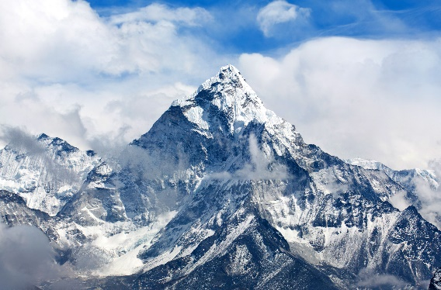
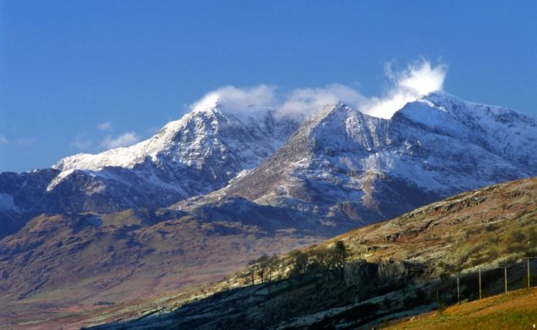

VS

