My Best Memories by Thomas

One of my favourite memories is when I went to Florida with my family when I was 8. We went to all the Disney and Universal parks and had a great time in each one.
One of my favourite rides was the Rock ‘n’ Rollercoaster in Disney Studios. It was the first time I’d been on a rollercoaster that went upside down. Before I went on the ride, I was really nervous because it was an indoor rollercoaster and it was in the dark which worried me because I didn’t know where we were going. It was just my mum and me that went on the rollercoaster and we both absolutely loved it because it was really fast and I hadn’t even realised we had gone upside down until after the ride had ended. My mum told me we had gone on 6 loops and I hadn’t even noticed. I loved the ride so much that we went on it again.
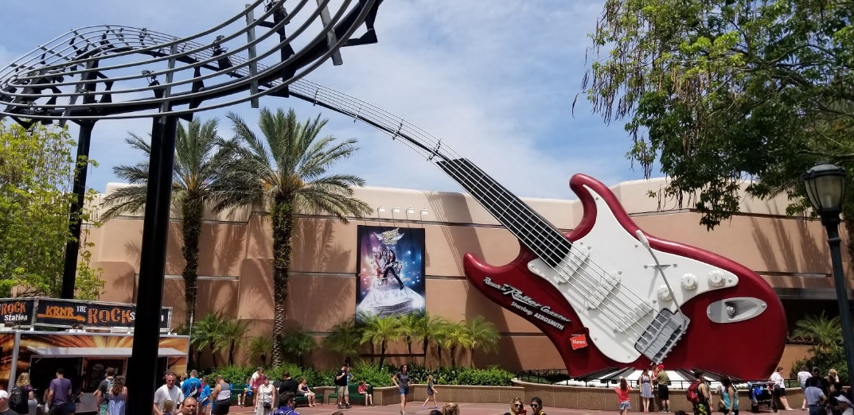
Another great memory from Florida was going to Volcano Bay waterpark. It had only just opened a few months prior and some of the water slides were like none we had ever been on before. We could access the rides by using a special waterproof wristband that lit up when we scanned it on a machine at the entrance. These were great because you didn’t need to stand in a queue for the slides.
One of my favourite waterslides was one that all five of us (except Grace, because she was a baby and was looked after by a friend who was with us) could go on. We all sat in a giant rubber ring and went around the slide which was pushed by water jets. There were some really big drops and we laughed all the way around it. We went on that water slide about 5 times because it was so much fun.
