This term we were going to look at STILL LIFE DRAWINGS. You could create an “ARTIST PAGE” -Find out information about an artist, collect pictures and make an arrangement of their work. Think about an interesting way to display it.
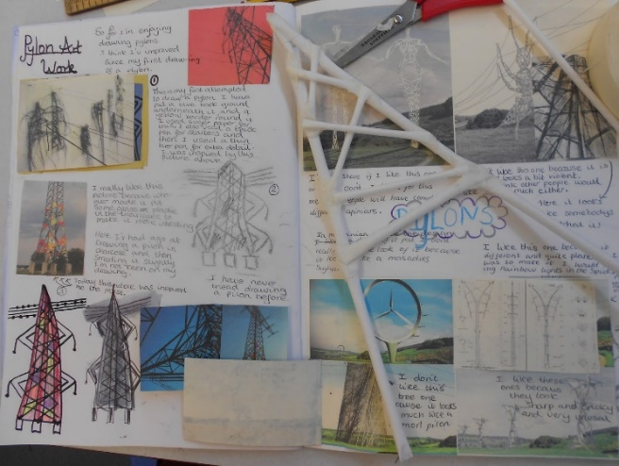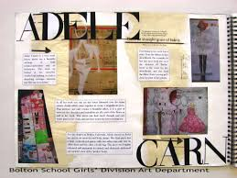
Could you use flaps, could you colour the background in their style? Try to recreate part of their picture. Try it in a different media, e.g. pencils, pastels, paints, make it 3D etc. Make notes about what colours the artist uses and what you like about the pictures. How do they make you feel? Show some of the pictures they are famous for?

These are some still life artist suggestions that you may want to use for your Artist page, or you could choose someone else to look at:

Henri Matisse – you may remember looking at some of Matisse’s work previously in school.
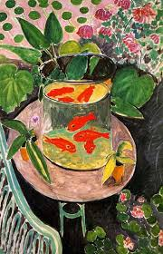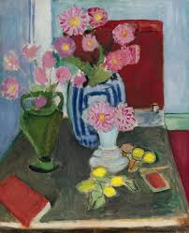

Maya Kopitseva – A Russian still life artist who was born in 1924
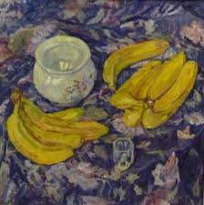
Nigel Humphries – modern day still life artist
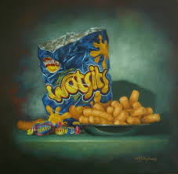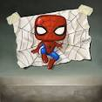
Still life art can be anything that stays still for you to draw! Have a go and see what interesting objects you can draw and send them to me!

