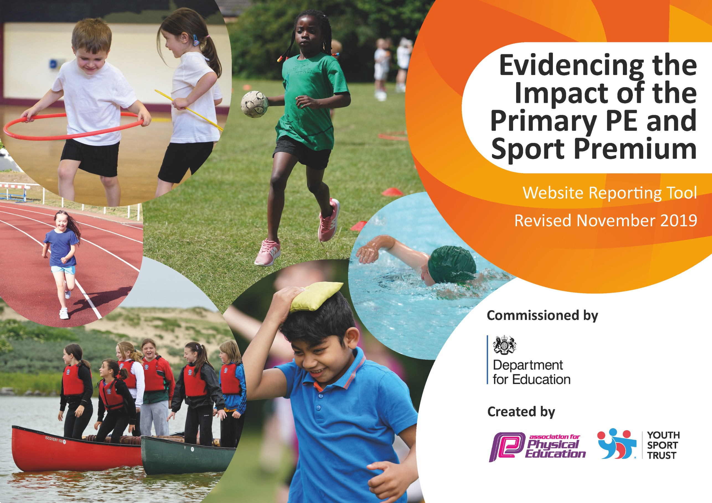
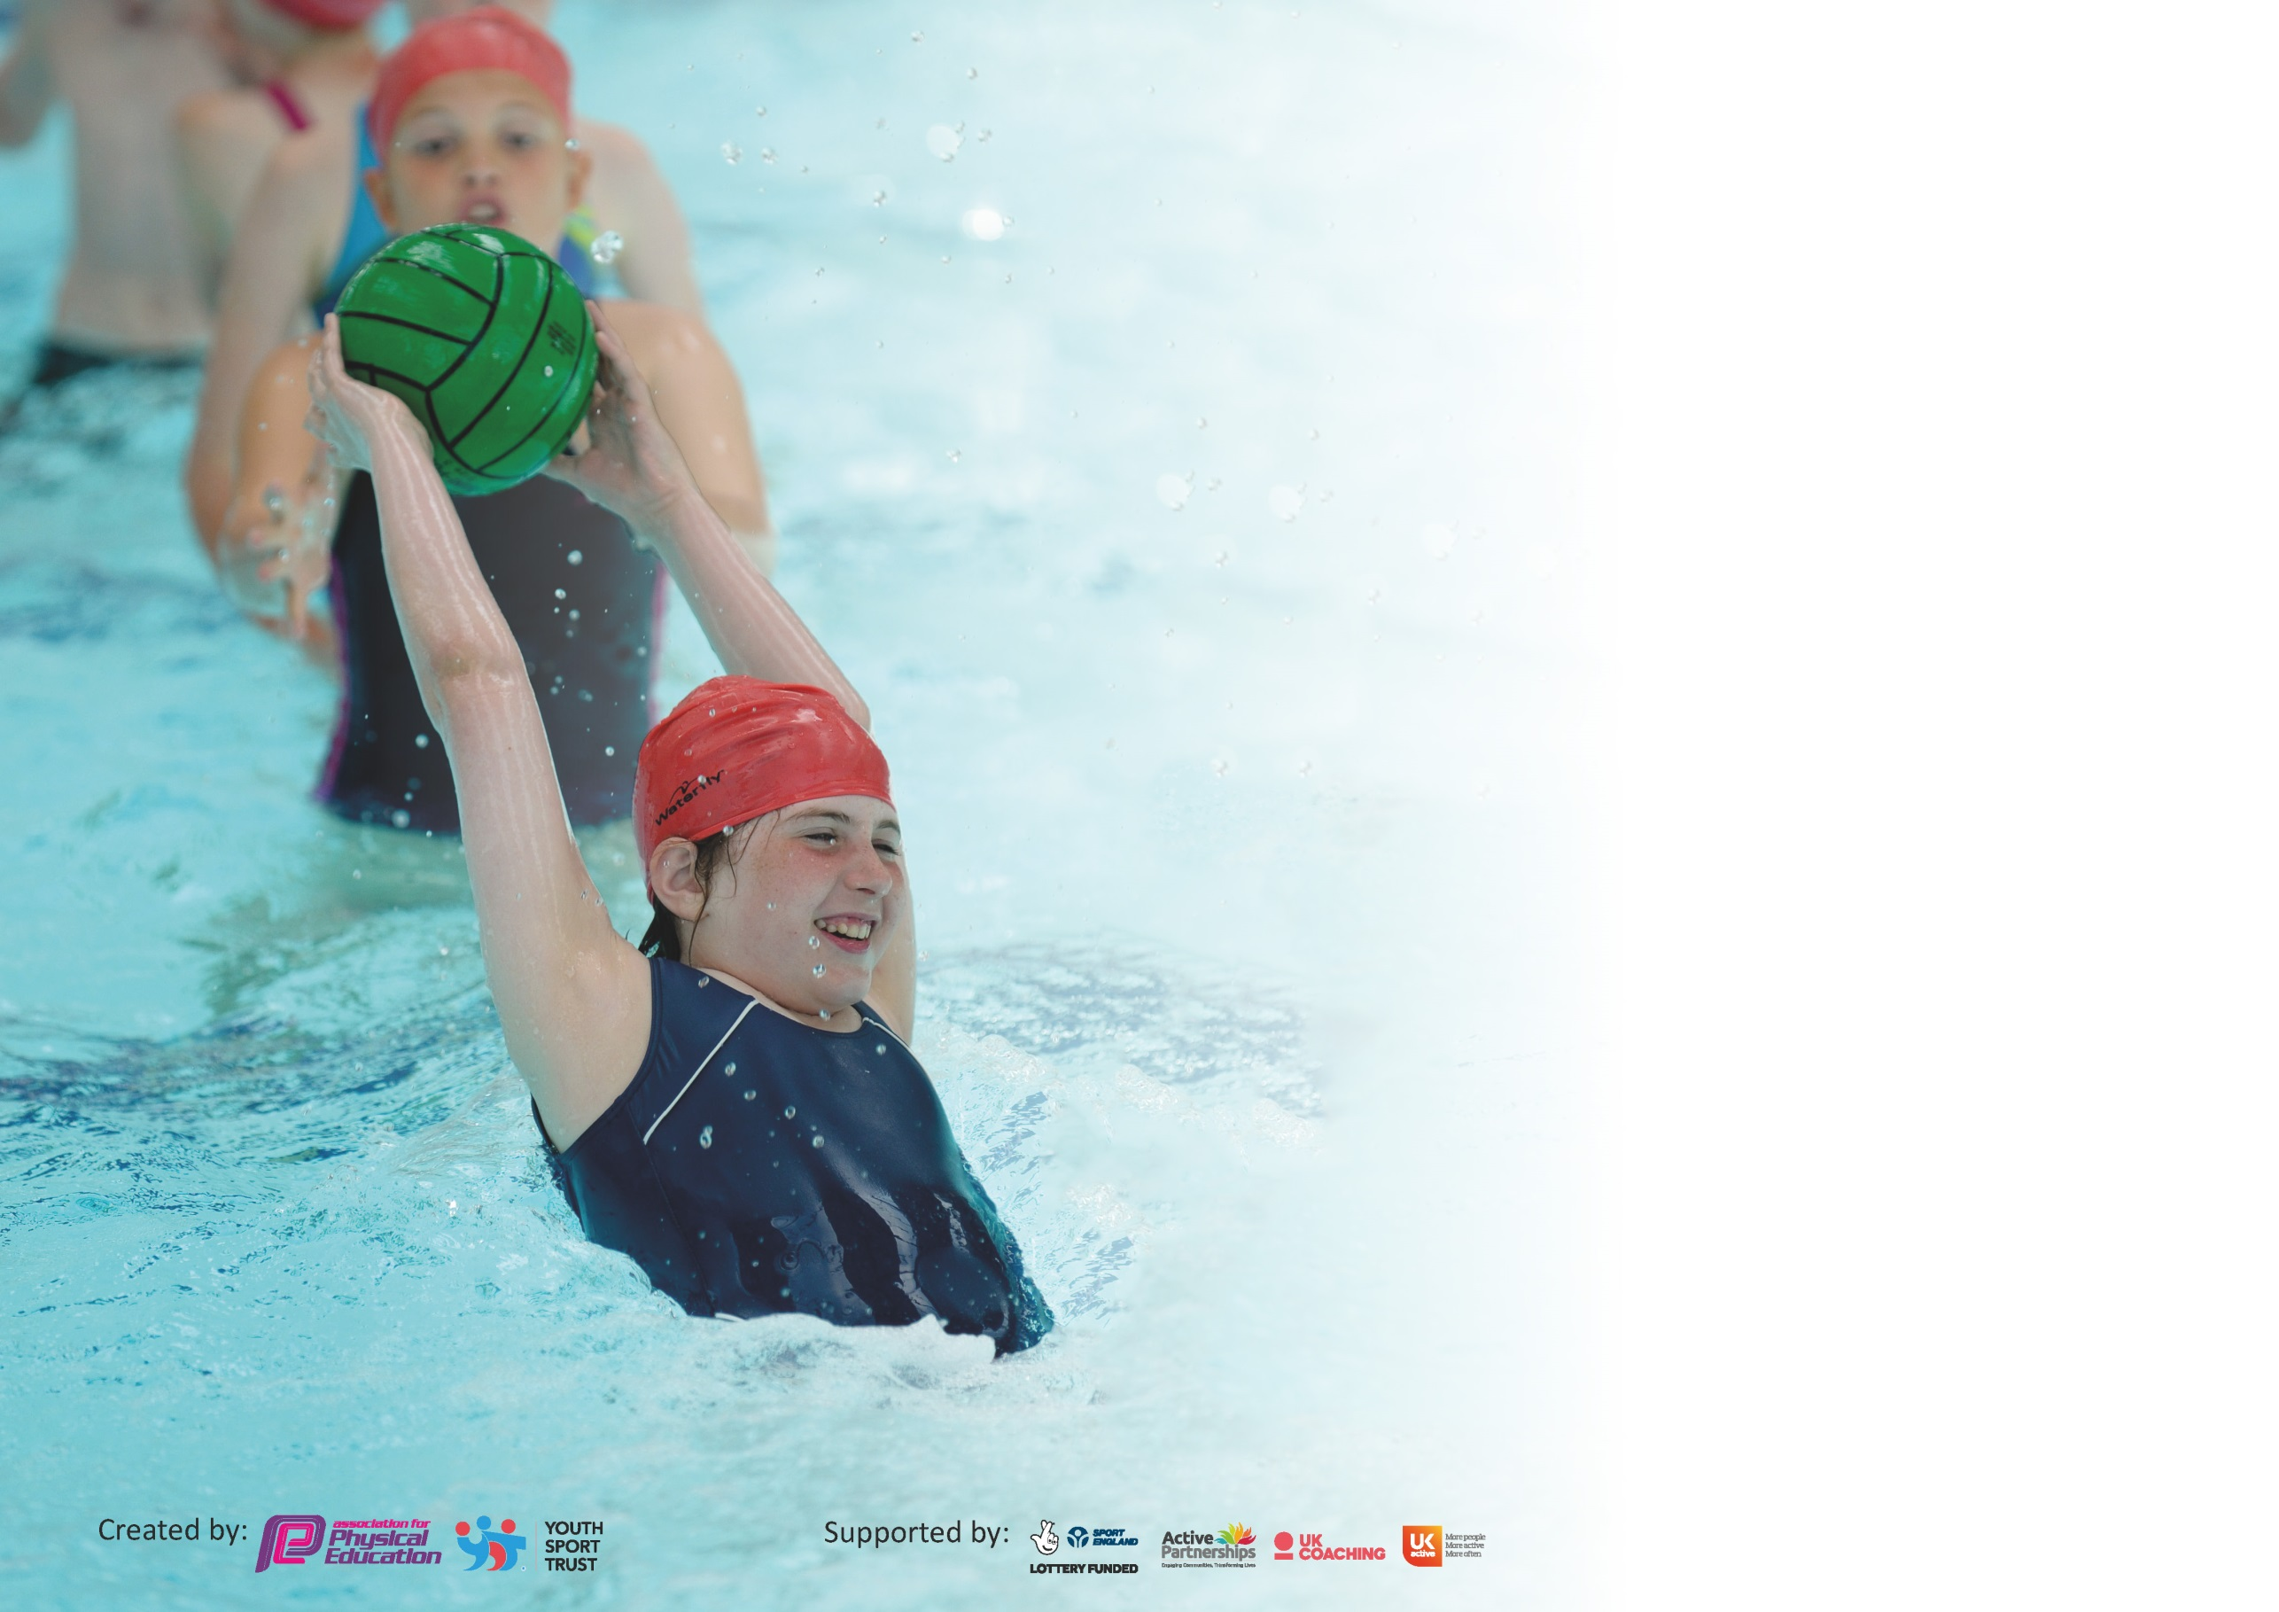

It is important that your grant is used effectively and based on school need. The Education Inspection Framework (Ofsted 2019 p64) makes clear there will be a focus on ‘whether leaders and those responsible for governors all understand their respective roles and perform these in a way that enhances the effectiveness of the school’.

Under the Quality of Education criteria (p41) inspectors consider the extent to which schools can articulate their curriculum (INTENT), construct their curriculum (IMPLEMENTATION) and demonstrate the outcomes which result (IMPACT).

To assist schools with common transferable language this template has been developed to utilise the same three headings which should make your plans easily transferable between working documents.

Schools must use the funding to make additional and sustainable improvements to the quality of Physical Education, School Sport and Physical Activity (PESSPA) they offer. This means that you should
use the Primary PE and Sport Premium to:

- Develop or add to the PESSPA activities that your school already offer
- Build capacity and capability within the school to ensure that improvements made now will benefit pupils joining the school in future years

Please visit gov.uk for the revised DfE guidance including the 5 key indicators across which schools should demonstrate an improvement. This document will help you to review your provision and to report your spend. DfE encourages schools to use this template as an effective way of meeting the reporting requirements of the Primary PE and Sport Premium.

We recommend you start by reflecting on the impact of current provision and reviewing the previous spend.

Schools are required to publish details of how they spend this funding as well as on the impact it has on pupils’ PE and sport participation and attainment by the end of the summer term or by 31st July 2020 at the latest.

We recommend regularly updating the table and publishing it on your website throughout the year. This evidences your ongoing self-evaluation of how you are using the funding to secure maximum, sustainable impact. Final copy must be posted on your website by the end of the academic year and no later than the 31st July 2020. To see an example of how to complete the table please click HERE.

Support for review and reflection - considering the 5 key indicators from DfE, what development needs are a priority for your setting and your pupils now and why? Use the space below to reflect on previous spend and key achievements and areas for development.

Key achievements to date until July 2020: | Areas for further improvement and baseline evidence of need:
-Premier Sports coaching staff continue to deliver a high standard of physical education to children and teaching staff’s proficiency has continued to improve.  -The range of after school and before school sports clubs has increased with a range of possibilities open to all children (Although, due to COVID restrictions, this was suspended from March 2020, pupils present in school received daily activities set up by Premier Sports).  -Pupils took part in football, netball and a whole range of intra school competitions  -The schools PE equipment has been improved and extended to include a wider range of sporting opportunities.  -The number of SEN and Pupil Premium pupils taking part in after school and before school clubs has improved-consistently above 50% attendance before lockdown.  -Play Leaders were trained in delivering a range of sporting activities during lunch times. | -To monitor and further improve pupil participation during lunch time activities provided through the school Play Leader system, especially those pupils who are least active (increase by 10% participation). Awards through certification to further promote participation.  -To ensure that at least 35% of pupils attend extra-curricular sporting activities-the percentage of pupils taking part will be monitored once clubs are open to pupils.  -To include at least two opportunity for pupils to take part in a personal challenge activity.  -To continue and extend the opportunities for pupils to take part in extra-curricular competition (both competitive and non-competitive)-at least 4 opportunities during the year-many of these will be virtual competitions to begin with.  -To continue providing pupils with opportunities to take part in intra-school competition (at the end of PE units of work)-classes setting a score for another class to compete against, until COVID restrictions are relaxed.

Meeting national curriculum requirements for swimming and water safety.
What percentage of your current Year 6 cohort swim competently, confidently and proficiently over a distance of at least 25 metres?  N.B. Even though your pupils may swim in another year please report on their attainment on leaving  primary school at the end of the summer term 2020. | 89%
What percentage of your current Year 6 cohort use a range of strokes effectively [for example, front crawl, backstroke and breaststroke]? | 82%
What percentage of your current Year 6 cohort perform safe self-rescue in different water-based situations? | 88%
Schools can choose to use the Primary PE and Sport Premium to provide additional provision for swimming but this must be for activity over and above the national curriculum requirements. Have you used it in this way? | Yes/No

Action Plan and Budget Tracking
Capture your intended annual spend against the 5 key indicators. Clarify the success criteria and evidence of impact that you intend to measure to evaluate for pupils today and for the future.

Academic Year: 2020/21 | Total fund allocated: £17,704 | Date Updated:
Key indicator 1: The engagement of all pupils in regular physical activity – Chief Medical Officer guidelines recommend that primary school pupils undertake at least 30 minutes of physical activity a day in school |  |  |  | Percentage of total allocation:
£15,400 + £420

89%

Intent | Implementation |  | Impact
Your school focus should be clear what you want the pupils to know and be able to do and about  what they need to learn and to  consolidate through practice: | Make sure your actions to achieve are linked to your intentions: | Funding allocated: | Evidence of impact: what do pupils now know and what can they now do? What has changed? | Sustainability and suggested next steps:
Introduce further sporting/physical activity opportunities, through Play Leaders, additional coaching opportunities, teacher-led activities, during lunch times to ensure pupil physical activity.  Aims:  - Improve physical fitness levels  - Improve concentration levels  - Relieve stress and improve emotional wellbeing. | -Liaise with Premier Sports and IC to train up Year 6 Play Leaders for lunchtime activities.  -Set up a timetable for Play Leaders and sporting/physical activities available during lunch times-set up in preparation for relaxation of COVID restrictions (provide midday assistants with games/activity packs for classes to use in the meantime).  -Discuss the use of ‘BBC Supermovers’ and resources from the Youth Sports Trust for active learning in the classroom.  -Introduce a ‘Sports’ Council’ with the job of assessing participation in sport across the school. Use Year 6 pupils to begin with-discuss how to engage as many pupils as possible in physical activity. | Premier Sports-lunchtime provision  £15,400+VAT  IC-cost £15 per lunchtime session 3½ hours per week-£52.50 per week-Autumn term to begin with. £420 | Evidence: Registers of attendance in lunch time activities, active playgrounds, certificates for participation (Active8), teacher questionnaires, pupil questionnaires.  Impact:
To purchase and update new play equipment to ensure that Play Leaders have a range of materials to select from for lunch time activities. | -Organise and carry out a PE equipment amnesty to ensure the most is made of existing equipment.  -Carry out an audit of equipment (Premier Sports and Mr Colligan included in this process), ensuring equipment matches curriculum requirements effectively. |  | Evidence: Audit of PE equipment, effective resourcing of PE lessons and lunch time activities.  Impact:
Key indicator 2: The profile of PESSPA being raised across the school as a tool for whole school improvement |  |  |  | Percentage of total allocation:
3% Additional Costing
86% (Part of Premier Sports Costs)
Intent | Implementation |  | Impact
Your school focus should be clear what you want the pupils to know and be able to do and about  what they need to learn and to  consolidate through practice: | Make sure your actions to achieve are linked to your intentions: | Funding allocated: | Evidence of impact: what do pupils now know and what can they now do? What has changed? | Sustainability and suggested next steps:
Continue improved focus upon physical education through lessons led by specialist coaches (training teachers as part of the process)-pupils to be engaged in physical education and enjoy sessions.  Increased competitive and participatory opportunities for school sport-both inter and intra sport-pupils to demonstrate the values and characters involved in sport (virtual competitions and personal best activities initially due to COVID restrictions).  To further highlight the benefits of being physically active to pupils-pupils to be more active in school and demonstrate better concentration and focus in school. | Staff trained and lead effective Physical Education sessions due to specialist support from Premier Sports coaching staff.  Sporting opportunities well-advertised and additional sporting rewards, certificates, photographs celebrated during weekly assemblies.  Intra-school competitions organised throughout the year and across the year groups-Premier Sports to organise for the end of each unit of work-class vs class via a notice board of times, distances, results etc.  To organise a range of physical activities and personal competitions during both lunch times and curriculum times. | Premier Sports coaching provision  £15,400+VAT  Edsential virtual competitions: £  Freddie Fit £500 (if and when possible due to COVID restrictions) | Evidence: pupil questionnaire, club attendance registers, lunch time registers, teacher questionnaire/discussions, competition registers.  Impact:

Key indicator 3: Increased confidence, knowledge and skills of all staff in teaching PE and sport |  |  |  | Percentage of total allocation:
Premier Sports 86%

No Additional Cost
Intent | Implementation |  | Impact
Your school focus should be clear | Make sure your actions to | Funding | Evidence of impact: what do | Sustainability and suggested
what you want the pupils to know | achieve are linked to your | allocated: | pupils now know and what | next steps:
and be able to do and about | intentions: |  | can they now do? What has
what they need to learn and to |  |  | changed?
consolidate through practice:
Deliver a curriculum support plan, in liaison with Premier Sports Coaching to ensure that outstanding Physical Education is being delivered across the school.  Aims:  -Improved teacher confidence  -Progressive, effective PE curriculum  -Increased subject knowledge and ability to deliver effective PE sessions  -Pupils progress at the expected rate or more | CPD through Premier Sports’ curriculum provision across the year. (Each class to receive one session of PE per week-coaches will deliver sessions and support teaching and teaching assistant staff in improving their understanding and delivery of the subject)  Pupil progress monitored regularly and evidence collated for accuracy.  Premier Sports’ coaching staff to work with midday assistants in the delivery of sporting and physical activities during lunch times-once possible. | Premier Sports coaching-2 full days and 4 clubs  £15,400+VAT | Evidence: pre and post support comments, lesson observations, pupil and staff questionnaires, scrutiny of planning, assessment materials (video, photographs, teacher notes)  Impact:
Key indicator 4: Broader experience of a range of sports and activities offered to all pupils |  |  |  | Percentage of total allocation:
 |  |  |  | No cost incurred
Intent | Implementation |  | Impact
Your school focus should be clear | Make sure your actions to | Funding | Evidence of impact: what do | Sustainability and suggested
what you want the pupils to know | achieve are linked to your | allocated: | pupils now know and what | next steps:
and be able to do and about | intentions: |  | can they now do? What has
what they need to learn and to |  |  | changed?:
consolidate through practice:
Taster sessions in a range of different sporting opportunities. To take place at lunch times and led by coaching staff and Play Leaders.  New ‘PE At Home’ tab created on the school website, providing opportunities for parents and children to remain active outside of school, during isolation and/or lockdown.  - | Premier Sports/Mr Colligan/Midday Assistants/Play Leaders to lead several new activities, such as:  - Skipping  - Yoga  School ‘PE At Home’ portal created, providing further opportunities for parents and children to remain active at home-especially during lockdowns.  Active education opportunities. Provision of a range of active opportunities linked to different subjects-‘Supermovers’  Whilst COVID restrictions are in place, these activities will be used for smaller groups and the organisation and set up will be practised to ensure smooth transitions. | N/A  Taster sessions led by in-house staff  If taster sessions held by external providers, they will be free promotional activities (Once COVID restrictions allow) | Evidence  -Questionnaire identifying pupils who attend sporting clubs outside of school  -Registers for lunchtime activities illustrate a growing percentage of pupils attending.

Key indicator 5: Increased participation in competitive sport |  |  |  | Percentage of total allocation:
 |  |  |  | No costs incurred
Intent | Implementation |  | Impact
Your school focus should be clear | Make sure your actions to | Funding | Evidence of impact: what do | Sustainability and suggested
what you want the pupils to know | achieve are linked to your | allocated: | pupils now know and what | next steps:
and be able to do and about | intentions: |  | can they now do? What has
what they need to learn and to |  |  | changed?:
consolidate through practice:
Increase the number and breadth of competitions made available. | Enter new competitions-virtual competitions to begin with.  KS2 Cross country competitions-set up between classes, with times being recorded and shown on sport notice board.  Sign up for sporting events through the Wirral Games portal/Edsential (Developmental and Competitive events)-virtual to begin with.  Set up a timetable of personal best competitions that pupils can try at different times throughout the year.  Premier Sports to run Intra-school competitions to provide competition between year groups. | Premier Sports  School Games portal is free of charge  Transport arrangements-parents to take pupils if and when able. | Evidence: Competition entry sheets, record of attendees, social media and VLE, notice boards evidence, newsletters.  Impact:

Signed off by
Head Teacher: | Danielle Evans
Date: | 2.9.20
Subject Leader: | David Bettridge
Date: | 2.9.20
Governor: | Neil Kirkham
Date: | 2.9.20

