Federation Objectives for 2019-20
- To continue to work together with a relentless focus on raising standards for all groups of children, in all schools across the federation
- To further develop our procurement procedures
- To develop additional community links with local organisations (including universities and secondary schools)
- To maximise communication between the schools to drive forward whole school improvement
- To promote well-being and the part we can play in ensuring everyone is fully supported and can fulfil their role efficiently and effectively
- To continue to consolidate and further develop cross-school links
- To develop collaboration between the caretakers/site managers
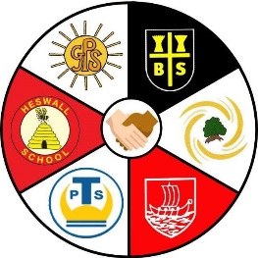 South Deeside Primary School Federation
2018-19 Federation Collaboration Overview
 | Autumn | Spring | Summer
Inset | IDL maths  Safeguarding  SES writing  No More marking  CSE training | Science Capital  CAHMS- School Refusal  Online Mental Health Training | Prevent  DT- Inventors Club  Stonewall
Moderation | Baseline F2  Y6 writing |  | Writing Moderation
Sharing Good Practice | KS1/Y3 Attainment  Maths Lead Project  Y6 teachers’ maths  GD Writing Science  SEND Cluster  Growth Mindset | Y6 teachers’ maths Outstandingly Happy Schools Project (Thingwall/Heswall) | Outstandingly Happy Schools Project (Thingwall/Heswall)  CPOMS demonstration  NQT support  DT (Inventors)
Monitoring | Science lesson observations Safeguarding audit |  | School Review  SATS administration  Safeguarding audits  Reading Audit
Events | Braddock Cup (netball)  Uganda Assemblies Science Under the Stars assemblies | Lantern making  Science Under the Stars  11 by 11 Launch  Y6 Maths Bee  Y6 Spelling Bee | Coast to Country Dodd Cup (football)  Hi-Impact filming C2C  Author visit  Deeside Litter Pick  Music festival  Art Exhibition
There are also termly Headteachers’ meetings, Admin. Team meetings, School Direct Mentor meetings and Heads & Chairs’ meetings

